WORKING WITH DOCKER

1. First, in order to ensure the downloads are valid, add the GPG key for the official Docker repository to your system:  
     
   $ curl -fsSL https://download.docker.com/linux/ubuntu/gpg | sudo apt-key add –
2. Add the Docker repository to APT sources:

$ sudo add-apt-repository "deb [arch=amd64] https://download.docker.com/linux/ubuntu $(lsb_release -cs) stable"

1. Next, update the package database with the Docker packages from the newly added repo:

$ sudo apt-get update

1. Make sure you are about to install from the Docker repo instead of the default Ubuntu 16.04 repo:

$ apt-cache policy docker-ce

1. Finally, install Docker:  
     
   $ sudo apt-get install -y docker-ce
2. Check that it’s running:

$ sudo systemctl status docker

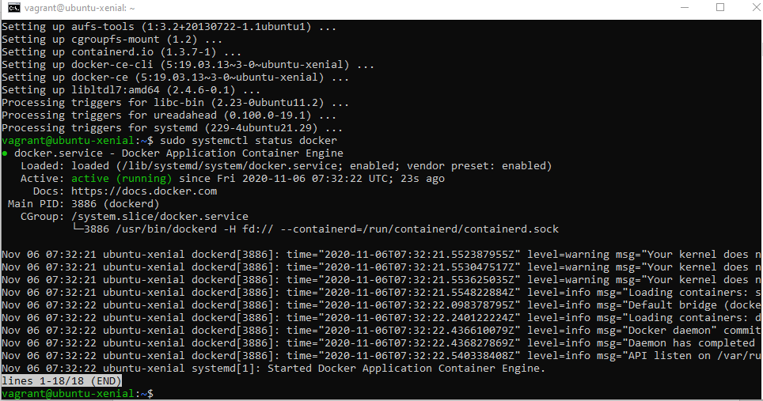

1. Executing the Docker Command Without Sudo

If you want to avoid typing sudo whenever you run the docker command, add your username to the docker group:

$ sudo usermod -aG docker ${USER}

1. To apply the new group membership, you can log out of the server and back in, or you can type the following:

$ su - ${USER}

1. If you need to add a user to the docker group that you’re not logged in as, declare that username explicitly using:

$ sudo usermod -aG docker username

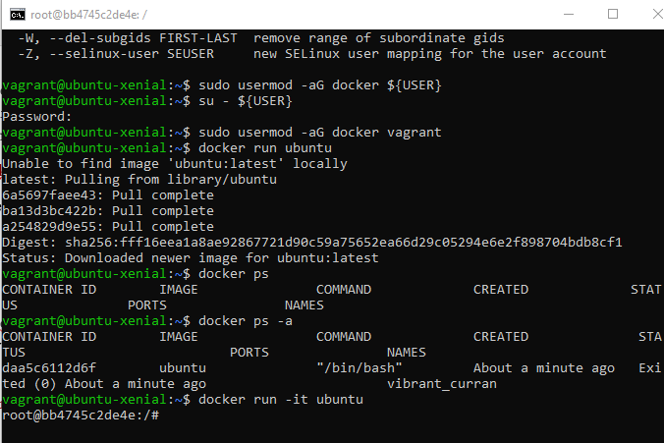

ATISHAY JAIN

500067694

R171218030

CSE, DEVOPS